Rigging tutorial

Add bones

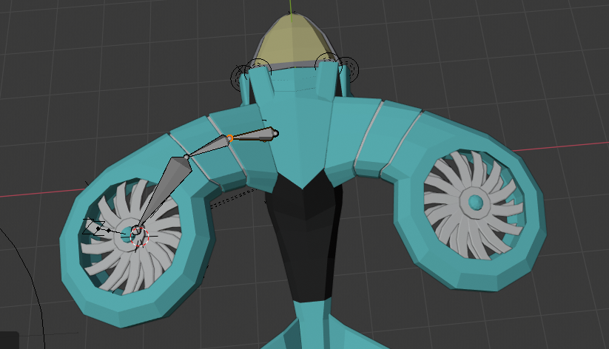

Ensure to apply the modificer to the the wings and blades before you do the next step.

Name the bones, wing.l

